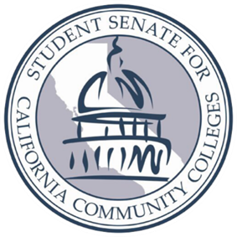
Student Senate for California Community College
presents
ADVOCACY DAY

Location: State Capitol Sacramento, CA 95605
Date: Thursday May 2, 2019
Time: 9AM -5PM
AGENDA
TIME | DISCRIPTION | LOCATION
9AM – 12PM | BUDGET AND FISCAL REVIEW  SUBCOMMITTEE NO. 1 ON EDUCATION | ROOM #3191
9AM – 12PM | LEGISLATIVE VISITS | CAPITOL
12PM – 1PM | LUNCH  (On your own) | RECOMMENDED: STATEHOUSE at the Capitol
1PM – 2PM | PRESS CONFERENCE / RALLY  for Senate Bill 291 | SOUTH STEPS of the CAPITOL
2PM – 5PM | LEGISLATIVE VISITS  Continued… | CAPITOL

Legislative Visits are scheduled through the Legislative Affairs Directors for each Region of the SSCCC. To contact your Legislative Affairs Director for your region and for more information go to www.studentsenateccc.org

